Social Media Kit Content

#Microbes are EVERYWHERE & important for the #foodsystem🍅, crop & livestock production🌾🐮, #soilhealth & human #guthealth🌱🙋‍‍ and even in the fight vs #ClimateChange  #CIRCLESEU proudly raises the profile of the #microbiome 🙌 www.circlesproject.eu | 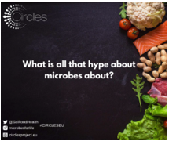
The microbiome is ESSENTIAL in our #foodsystem for:  🌱Soil & plant health  🌾 Crop production  🐮 Livestock health  🍞 Food production  🥕Human health  🗑#Foodwaste composting  🌡 #ClimateChange mitigation  #CIRCLESEU www.cirlesproject.eu | 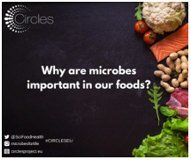
Microbial communities in #farm animals are likely connected👩‍🌾  #CIRCLESEU is exploring poultry & swine food chains to improve the health & wellbeing of all parts of the #foodsystem🐔🐷  Find out more on www.circlesproject.eu | 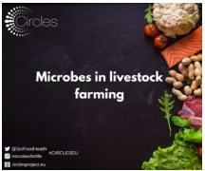
From soil to oceans, #microbes are everywhere🦠  Thanks to its overarching nature, knowledge of the potential of #microbes throughout the food chains will ensure the sustainability of our #foodsystems🌍  #BioeconomyStrategy #FOOD2030EU #CIRCLESEU | 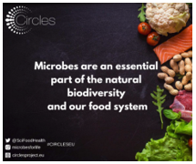
#CIRCLESEU is developing innovative #microbiome applications in the #foodsystem, to increase:  ♻️Sustainability of health & food systems  💭Microbiome knowledge  ✨New microbiome-based food & feed applications  ✅Reach #FOOD2030EU goals | 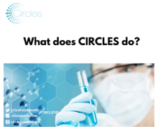
The #microbiome is a community of microscopic organisms in a defined habitat with distinct properties. The #gutmicrobiome includes  🦠Bacteria & yeasts  🦠Their individual functions (the compounds they produce)  🦠The beneficial effects of the compounds on #guthealth  #CIRCLESEU | 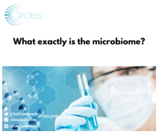
Everybody & everything is surrounded by #microbes  Understanding  🦠what microbes do, &  🦠how they interact with each other  will enable us to manage our planet’s resources to obtain our food & improve our health🤸‍♀️🍏  #CIRCLESEU👉https://circlesproject.eu | 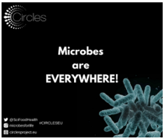
As we celebrate #microbes, let’s get acquainted with some unusual #microbial applications beyond #CIRCLESEU!  Scientists are studying #bacteria on the seafloor that eat methane, a greenhouse gas😮& #microbes living in compost that can help make biofuels⛽ | 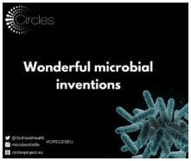
#Microbes are likely interconnected between  🌊Ocean waters  🦈Wild fishes  🐟Farmed fishes  🌍The wider marine #environment  #CIRCLESEU is exploring these links to improve the health & wellbeing of all parts of the #foodsystem  👉https://circlesproject.eu/ | 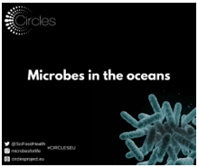
#DidYouKnow that researchers from #CIRCLESEU are looking into the importance of the #microbiome in the #foodsystem?  Microbiome research is important & has:  ⛰️Untapped potential  🔑The key to healthier living  🍀Limited discoveries  👉https://circlesproject.eu | 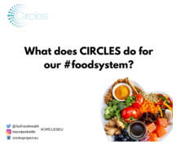
The world of #microbes is filled with untapped potential😮 #Microbiome research could lead to applications in many areas:  🌦Climate science & carbon cycling  ⛽ Sustainable energy & biofuels  ⚕Health & medicine: treatment of #NCDs & #AMR  #CIRCLESEU | 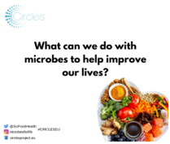
Microbial communities are essential for the health & wellbeing of ecosystems (like our body!)🦠  ⚖️When in balance, the ecosystem is doing well  🤒If individual species take over, they may cause illness or food spoilage in the #foodsystem  #CIRCLESEU | 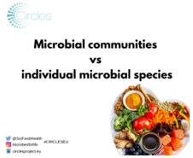
The soil is alive and full of microbes!🌱🦠  #CIRCLESEU is looking at how spinach & tomato🍅 production can be improved with the support of fungi or bacteria found on other plants 🔬 Reach #FOOD2030EU goals!  More info: https://circlesproject.eu | 